UAV - YellowScan LiDAR Data Workflow
This document is intended to serve as a guide and source of notes for processing the LiDAR generated by the YellowScan drone mounted LiDAR system.
Starting with ArcPro Workflow:
Step 1: Generate LAS Files
- Has already been generated for the arboretum
Step 2: Clip Area of flight as necessary
ArcPro Workflow:
- Create project **Need to be in C drive, unable to make edits when located in E drive or in Tree Research sharepoint, need to test out in onedrive
- "Create LAS Dataset"
  - Add 25-04-23_Arboretum.las as the input from: E:\GSL Projects\Projects - In Progress\Arboretum Project\export\250423_Arboretum.las
  - Save the .lasd somewhere logical in your project folder: titled arb_create_las_dataset.lasd
  - Run
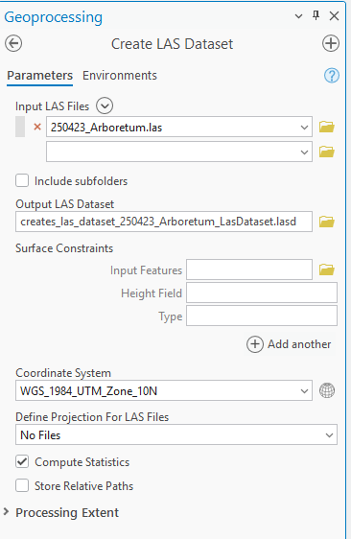
- “Extract LAS”
  - Input: arb_create_las_dataset.lasd
  - Target folder: new folder in project titled Extract LAS Folder
  - Output LAS Dataset: extracted_arb_las_dataset.lsd
  - Processing extent:
    - Draw extent
    - Draw bounds to area of interest within arb_create_las_dataset.lasd boundaries
  - Run
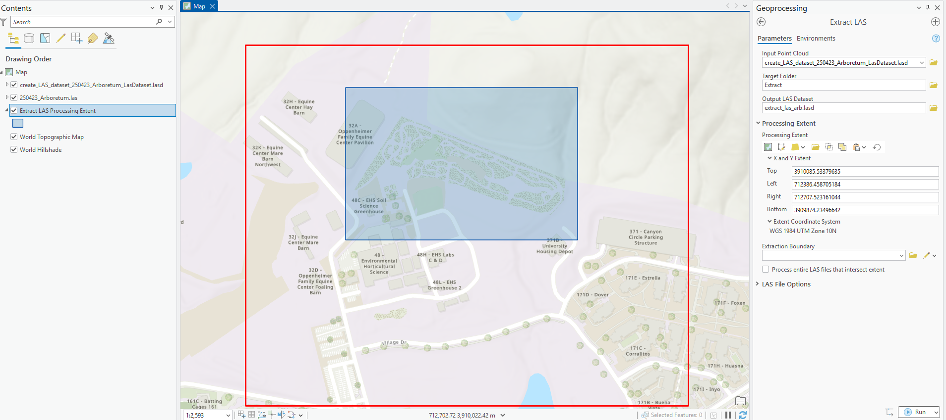
- “Classify LAS Ground” Tool
  - Input: extracted_arb_las_dataset.lasd
  - Ground Detection Method: Conservative Classification
  - Detection Algorithm: Latest
  - DEM Resolution: 10 meters (adjust if needed)
  - Compute Statistics: Enabled
  - Run
- View Ground Points Only
  - Select las dataset layer in contents pane: extracted_arb_las_dataset.lasd
  - Right click the layer > Properties
  - In Properties tab go to LAS Filter tab
  - Under Classification codes, select 2 Ground
    - If you do not see this, the classify las ground tool did not work
- Creating a Digital Terrain Model (DTM)
  - Use “LAS Dataset to Raster”
  - Input: extracted_arb_las_dataset.lasd filtered to the ground points via previous step
  - Output raster: DTM_extrac_lasda
  - Value Field: Elevation
  - Interpolation Type: binning, average, linear
  - Output data type: Floating Point
  - Sampling Type: Cell Size
    - Sampling Value: 1 (m)
    - Z factor: 1
- Creating a Digital Surface Model (DSM)
  - Use “LAS Dataset to Raster”
  - Input: extracted_arb_las_dataset.lasd filtered back to All points (right-click, under LAS Filters, select All Points)
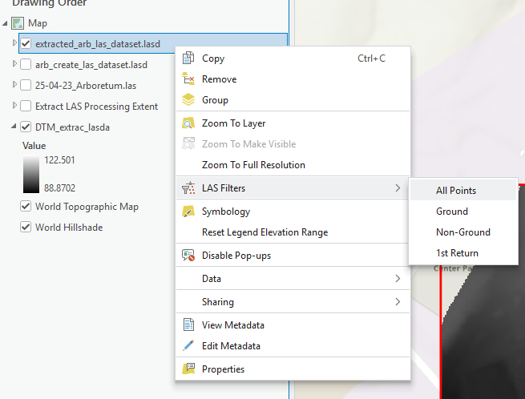
  - Output raster: DSM_extrac_lasda
  - Value Field: Elevation
  - Interpolation Type: binning, average, linear
  - Output data type: Floating Point
  - Sampling Type: Cell Size
    - Sampling Value: 1 (m)
    - Z factor: 1
- Canopy Height Model
  - 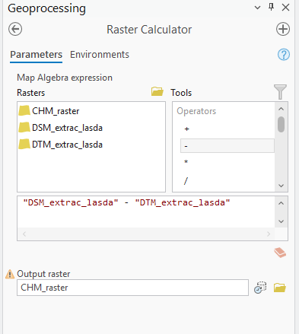
- **FOR CREATING INDIVIDUAL HEIGHT ESTIMATES OF TREES (weird)**
“Focal Statistics” tool: to help identify maximum canopy height of each tree
  - 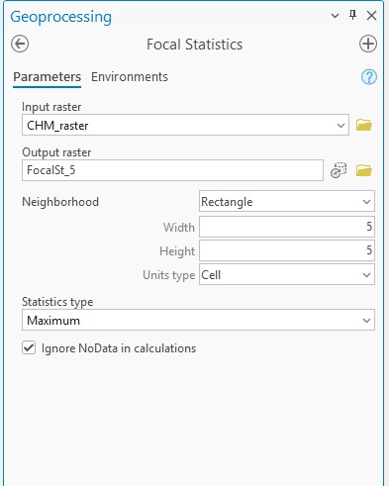
  - Start with 3x3 cell, repeat for 5x5 cell. 10x10 cell, 20x20 cell
- “Set Null” tool to remove values below 2m so that we are only looking at trees of significant height
  - 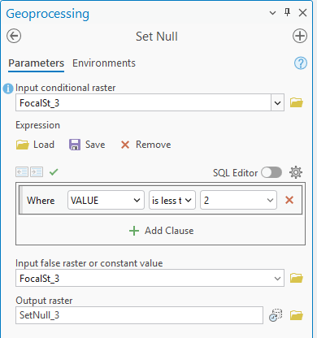
- Extract Tree Points using “Raster Calculator” with conditions
  - 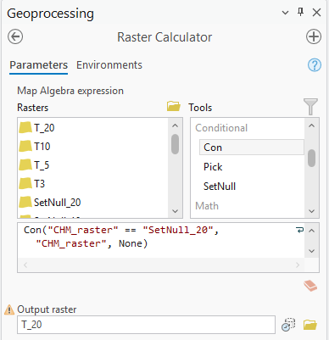
  - Repeat for 3, 5, 10, 20
  - Look at the pixel mapping generated for each level
    - Ideally want one pixel (with height) per tree
    - In this case, somewhere between 5 and 10 seems to do the job
      - Thus i will generate a FS6,7,8,9
      - And a setnull5, 6, 7, 8, 9
      - And indv. pixel layers for 6, 7, 8, 9 to generate a better model
      - May need to do combinations of different levels for different areas
GEDI footprints -> get max height of raster underneath for LiDAR data -> get corresponding height of tallest tree in area with manual and phone
- GEDI footprints only within arb boundaries: select by location > made new layer from this selection
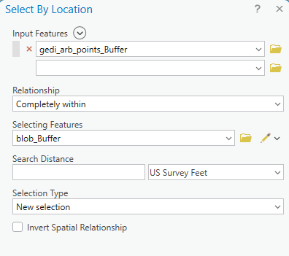
- Get max pixel value of LiDAR drone data from beneath GEDI footprints
  - “Zonal Statistics as Table”
  - 